**Average Temperature Weather Programme**

**Form**

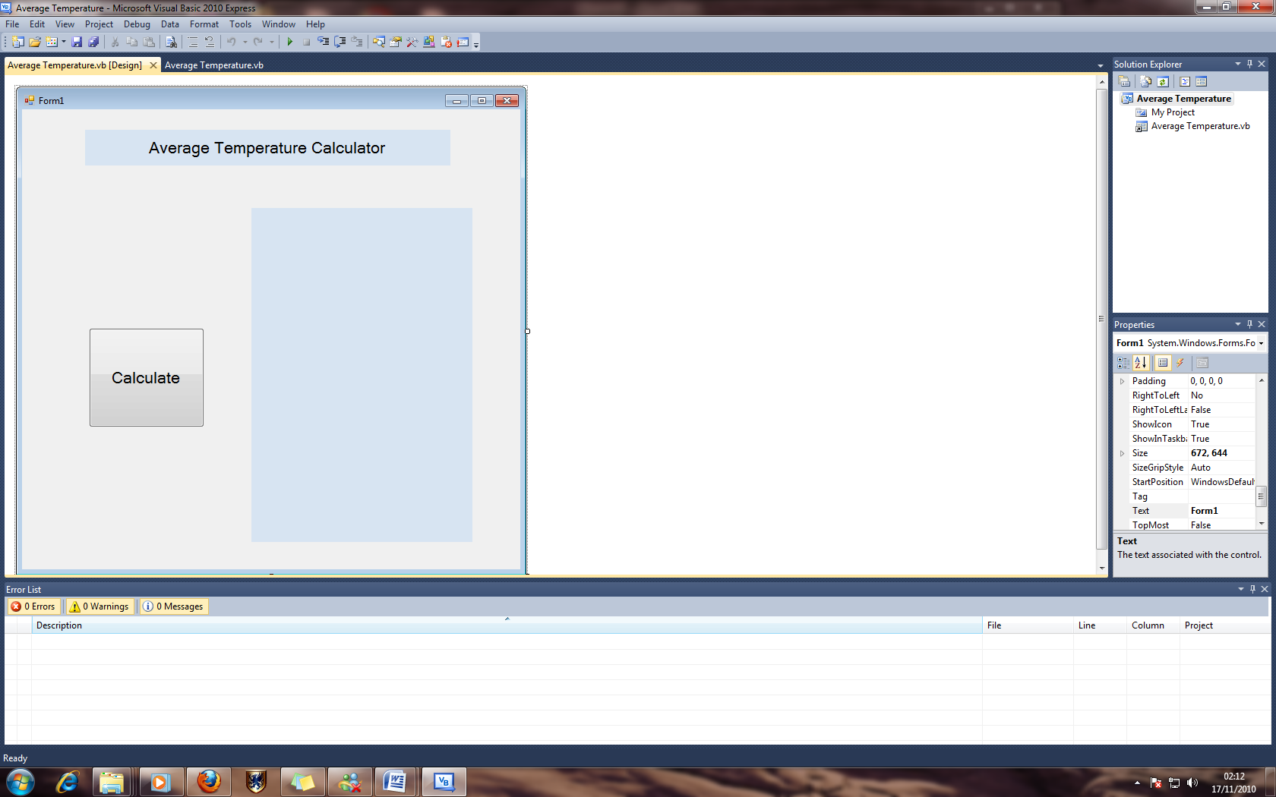

**Code:**

Public Class Form1

Dim Display As String

Dim Average As Single

Dim Degrees(7) As Integer

Dim Month As String

Dim Output As String

Dim ExpectedAverage As Single

Dim Message As String

Dim Change As Integer

Private Sub Button1_Click(ByVal sender As System.Object, ByVal e As System.EventArgs) Handles BtnCalculate.Click

Month = InputBox("Enter the Month Here", "Month")

Display = "Average temperature result for " & Month & vbNewLine

For C = 1 To 7

Degrees(C) = InputBox("Enter the Current Temperature", "Degrees")

Next C

Output = "7 Temperatures" & vbNewLine &

Degrees(1) & " Degrees" & vbNewLine & _

Degrees(2) & " Degrees" & vbNewLine & _

Degrees(3) & " Degrees" & vbNewLine & _

Degrees(4) & " Degrees" & vbNewLine & _

Degrees(5) & " Degrees" & vbNewLine & _

Degrees(6) & " Degrees" & vbNewLine & _

Degrees(7) & " Degrees" & vbNewLine

Average = Format((Degrees(1) + Degrees(2) + Degrees(3) + Degrees(4) + Degrees(5) + Degrees(6) + Degrees(7)) / 7, "#0")

If Month = "January" Then ExpectedAverage = 6

Change = Average - ExpectedAverage

If Average > ExpectedAverage Then

Message = "Average Temperature is " & Change & " Degrees " & "Greater than Expected Average for" & Month

ElseIf Average = ExpectedAverage Then

Message = "Average Temperature is Equal to Expected Average for " & Month

ElseIf Average < ExpectedAverage Then

Message = "Average Temperature is " & Change & " Degrees " & "Less than Expected Average for" & Month

End If

If Month = "June" Then ExpectedAverage = 14

Change = Average - ExpectedAverage

If Average > ExpectedAverage Then

Message = "Average Temperature is " & Change & " Degrees " & "Greater than Expected Average for" & Month

ElseIf Average = ExpectedAverage Then

Message = "Average Temperature is Equal to Expected Average for " & Month

ElseIf Average < ExpectedAverage Then

Message = "Average Temperature is " & Change & " Degrees " & "Less than Expected Average for" & Month

End If

Output = Output & Display & Average & " Degrees" & vbNewLine & _

"Analysis: " & Message & vbNewLine

lbloutput.Text = Output

End Sub

End Class

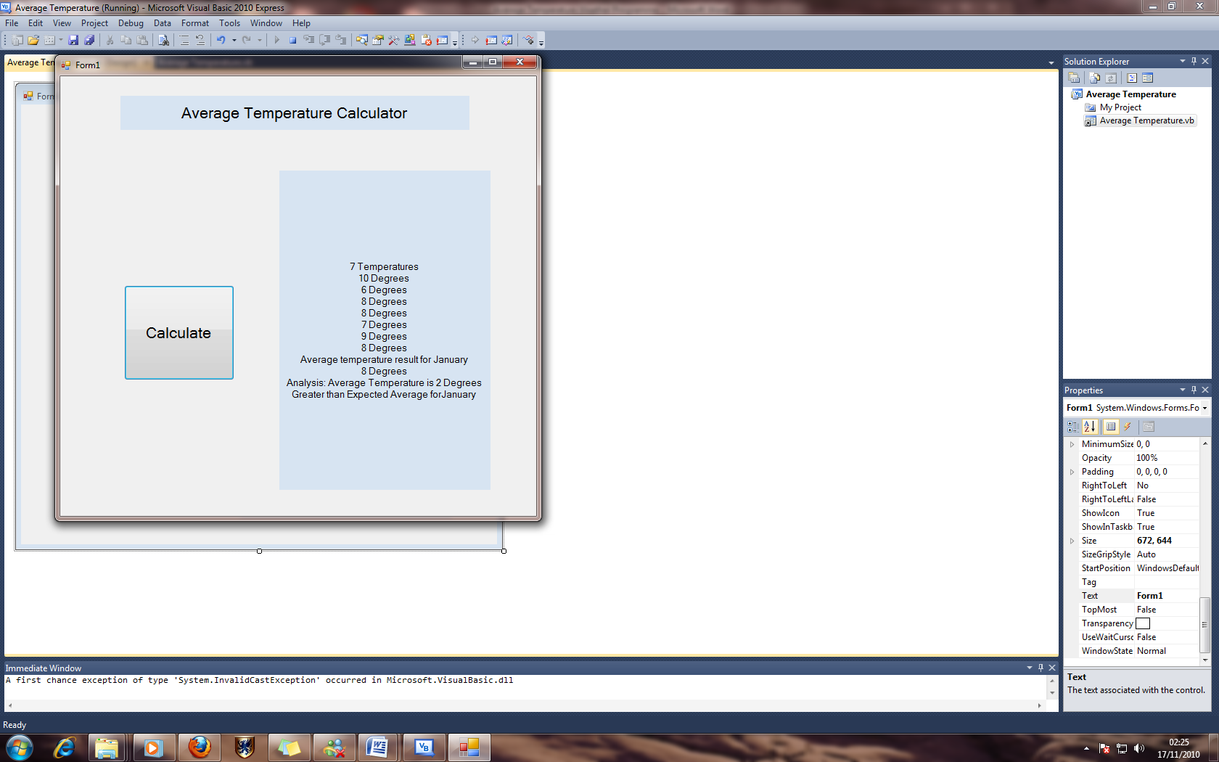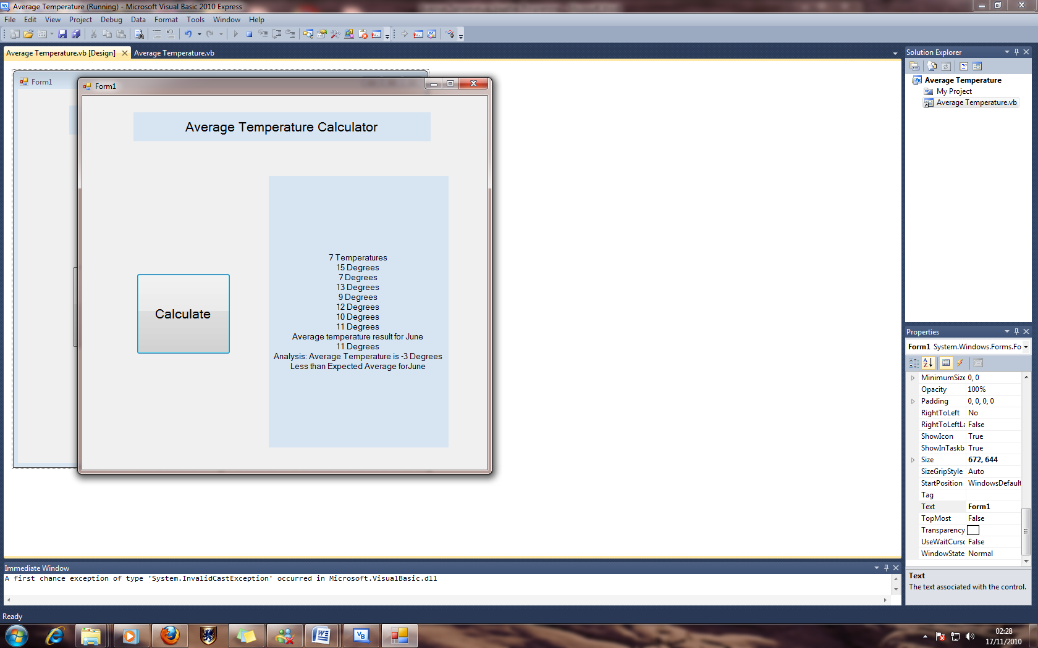**Examples**